MECH 420 Lab 1

Proximity Sensing

Sophie Lin

70196886

Sept. 26, 2023

TA: Hiroshan

Contents

Figures 2

Experimental Setup 3

Analysis of Results 5

Appendix 11

Appendix A - Excel Data 11

Appendix B – MATLAB Data Processing 11

Appendix C – Zoomed in MATLAB Plots 14

# Figures

Figure 1 - Experimental Setup 3

Figure 2 - Sampling Frequency = 20Hz 4

Figure 3 - IR Sensor: Output Voltage vs Distance to Target for all samples 5

Figure 4 - LED Sensor: Output Voltage vs Distance to Target for all samples 5

Figure 5 - Eddy Current Sensor: Output Voltage vs Distance to Target for all samples 6

Figure 6 - Capacitive Sensor: Output Voltage vs Distance to Target for all samples 6

Figure 7 - LED Sensor: Calibration Equation for all samples 8

Figure 8 - IR Sensor: Calibration Equation for all samples 9

# Experimental Setup

Figure 1 below shows the experimental setup used in this lab.

Figure - Experimental Setup

A digimatic indicator provided the reference position.

The proximity sensors include:

1. IR sensor
2. Laser (LED) sensor
3. Eddy current sensor
4. Capacitive sensor

The samples include:

1. Steel
2. Shiny Aluminum
3. Sand Blasted Aluminum
4. Shiny/Sand Blasted Aluminum
5. Acrylic

The samples were moved towards the sensors from 3mm to 0mm, then away from the sensors back to 3mm. The samples were moved **very slowly** to reduce the hysteresis error from the digimatic indicator. This is because the velocity the samples are moved at is directly proportional to the error in reference position.

Figure - Sampling Frequency = 20Hz

A sampling rate of 20 Hz was used to ensure enough data is collected, as shown in Figure 2 above.

Please see the MECH 420 laboratory manual for the full procedure.

# Analysis of Results

## Prepare one graph for each proximity sensor showing the sensor signal for all test targets as a function of distance between the sensor and the test targets. Use the distance measured by the dial gauge as the reference distance.

Figures 3 to 7 below show the sensor signal as a function of relative distance between digimatic indicator and samples.

Figure - IR Sensor: Output Voltage vs Distance to Target for all samples

Figure - LED Sensor: Output Voltage vs Distance to Target for all samples

Figure - Eddy Current Sensor: Output Voltage vs Distance to Target for all samples

Figure - Capacitive Sensor: Output Voltage vs Distance to Target for all samples

For each sensor, the output signal may be different depending on the material sample. Some materials produced the same sensor output, but other materials produced very different sensor output. This is due to the sensor physics. How the sensor detects distance impacts its performance on different materials.

Some sensors have more hysteresis errors than others. For example, a hysteresis loop is clearly visible on the plot for the capacitive sensor (Figure 6). However, a closer look at the plots show that every sensor has some hysteresis. Please see Appendix C for the zoomed in version of the plots for each sensor.

To find out more about how the plots were generated from the data, please see Appendix A and B.

## Compare your observations for all 4 sensors to the specifications in the data sheets and in this lab manual. Comment on range, linearity and hysteresis for each sensor.

|  |  |  |  |
| --- | --- | --- | --- |
|  | **Range** | **Linearity** | **Hysteresis** |
| **IR Sensor** | Datasheet: 2.04-7.62 mm  Experimentally, large changes in voltage are observed in the rated range, and the peaks all lie within this range. The curve shapes look exactly like the ones in the datasheet | Non-linear, likely polynomial  Non-linearity is worst for shiny Al. Almost linear for acrylic | small hysteresis  Hysteresis is worst for shiny Al. Very little hysteresis for acrylic. Out of all the metal samples, sand blasted Al has the least hysteresis |
| **LED/Laser Sensor** | Datasheet: 16-26 mm  Experimentally, all samples except acrylic have a linear response with a steep slope within the rated range.  Acrylic exhibits the response between 10-20mm and 23-26mm. This is because acrylic is not opaque which disrupts the sensor’s measurement because some light is reflected, and some light is transmitted | Very linear within the specified measuring range for all opaque samples | Small hysteresis  Hysteresis is only visible when the plot is very zoomed in. The amount of hysteresis error is similar for all samples |
| **Eddy Current Sensor** | Datasheet: 0-10 mm  Does not work on acrylic because it is non-conductive (straight line on plot)  All other samples produce large changes in voltage in this range. Al samples converge to a constant value of 9V at 2-3 mm while steel converges to 9V at around 6 mm. This means the actual range is less than the rated range | Not linear  Let x be the position where the output voltage reaches 9V. The curve can be approximated as linear between 0mm and x. For distances greater than x, the output is constant at 9V.  Experimental curves are similar to the ones in the datasheet | small hysteresis  Hysteresis is only visible when the plot is very zoomed in. The amount of hysteresis error is similar for all the metal samples |
| **Capacitive Sensor** | Datasheet: 2-15 mm  Experimentally, acrylic triggered the switch at around 1-2mm, while all other samples triggered at around 5-5.5mm. This fits the specifications | It is a proximity switch (high or low), so it does not have linearity | Lots of hysteresis  Hysteresis loop clearly visible on the plots without having to zoom in |

## Determine the calibration equation for both the LED position sensor and the IR reflective object detector for all 4 test targets.

For the LED sensor, Figure 7 below shows the calibration equation on top of the response for each sample within the specified range. The calibration equations are shown in the plot’s legend.

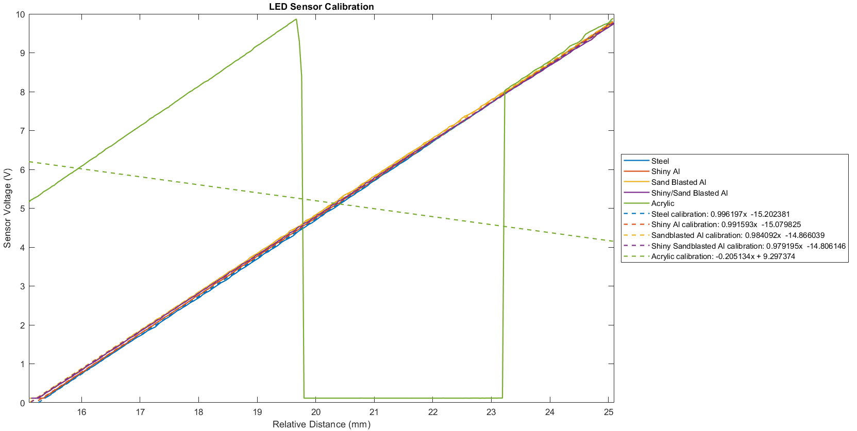

Figure - LED Sensor: Calibration Equation for all samples

Because the response is linear, MATLAB polyfit() function was used with a polynomial degree of 1. The calibration equations fit all the samples well except for acrylic. Acrylic reflects some light and transmits some light, so the response in the specified range cannot be modelled using a linear equation. The LED sensor is not suitable for measuring non-opaque materials because it relies on the reflection of light.

For the IR sensor, Figure 8 below shows the calibration equation on top of the response for each sample within the specified range. The calibration equations are shown in the plot’s legend.

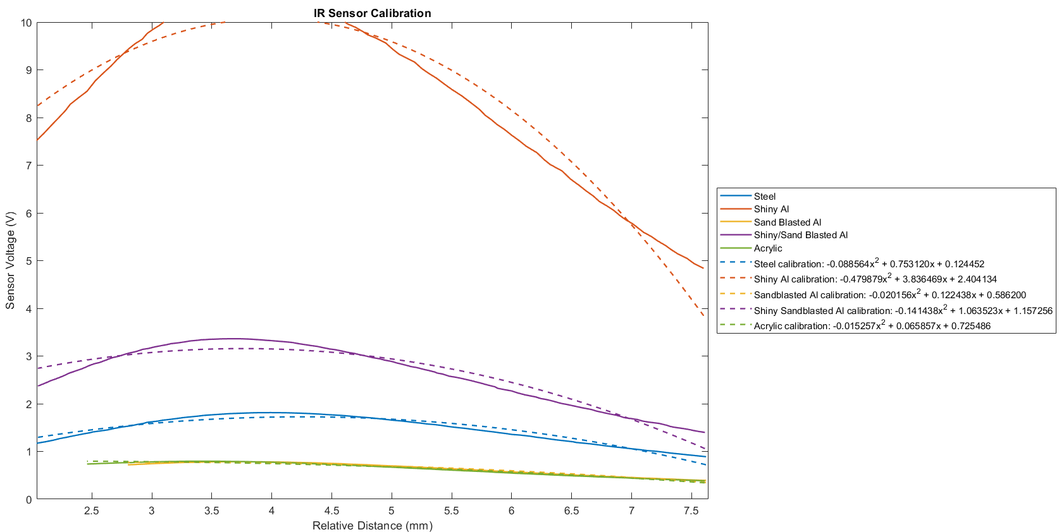

Figure - IR Sensor: Calibration Equation for all samples

Because the responses are non-linear, the MATLAB polyfit() function was used with a polynomial degree of 2. This is because proximity is proportional to the square of infrared light intensity. The calibration equations model the response very well for acrylic and sand-blasted aluminum. However, the error is higher for shiny Aluminum. This is because infrared radiation can pass through shiny Aluminum easier, while the sensor relies on infrared radiation that is reflected.

## What type of proximity sensor would you use for the following tasks? Explain.

### Detecting the presence of a conductive object.

Eddy current sensor would be suitable because it has high accuracy for conductive objects. However, if cost is a concern, then a capacitive sensor could work because we only need to know if the object is present. Otherwise, if the range needs to be greater, then LED sensor would be the only choice because its range is 16-26 mm, while the experimental range for eddy and capacitive sensors is less than 10 mm.

### Determining the approximate distance of an opaque object

I would use a LED sensor because it can reliably measure the distance of an opaque object. A capacitive switch would be reliable, but it cannot determine distance. Eddy current and IR sensors are not guaranteed to be reliable because we don’t know if the object is conductive or reflects infrared radiation.

# Appendix

## Appendix A - Excel Data

Snippet from Excel spreadsheet showing raw data for each material and sensor

Excel spreadsheet is attached below:



## Appendix B – MATLAB Data Processing

MATLAB code to read excel data using xlsread()

MATLAB code to process data within the sensing range

MATLAB code for curve fitting using polyfit() to determine the calibration equations

My MATLAB script is attached below:



MATLAB code for plots

## Appendix C – Zoomed in MATLAB Plots

Below are the zoomed-in versions of the MATLAB plots for each sensor

